**Q1-** Explain the statement “Stovepiped operations lead to stovepiped systems; stovepiped systems

Perpetuate stovepiped operations.”

The decision makers in stovepiped operations usually will take the decisions based on a particular portion of the organization, which is isolated from other portion, and the users will resist the change in the information systems unless there is a strong demand for the change.

Also the decision makers will gather the information from a narrow point of view about isolated functional area and because this area is not integrated, the systems will be stovepiped and that will perpetuate stovepiped operations.

**Q2-** Picture in your mind a pizza (or other food) delivery retailer of your choice. Using the knowledge you have based on your previous experiences with ordering pizza (or other food), combined with your general business understanding, try to guess what the value system level model for this enterprise will include. You may either draw a value system level model similar to Exhibit 2-2, or you may prepare a matrix as follows:

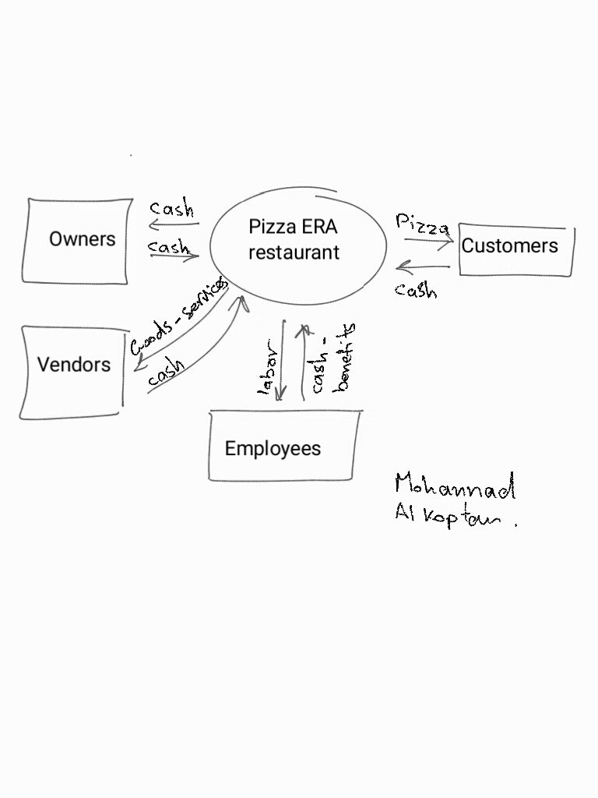

Where vendors supplies goods, raw materials and services (like 3ed party delivery company)

And the employee’s benefits can be non-cash items like insurance – tickets and others.

**Q3-**What is the difference between a stock inflow and a stock outflow? What types of events are associated with stock inflows and with stock outflows?

* + Stock Inflow: a resource that flow into the process cycle - Increment economic events increase resources (stock in-flows) Ex: for the payroll process the cash coming from finance department.
  + Stock outflow : a resource that flow out of the process cycle - Decrement economic events decrease resources (stock out-flows) Ex: the salaries and payments out of the payroll process to the employees is outflow stock.

**Q4**- Create an REA model (in either ER Grammar format or in ER diagram format) for Bowerkate

Corporation’s revenue cycle as described below. Be sure to include all relevant entities,

relationships, attributes, and participation cardinalities.

Cash

Sale

Cash

Receipt

Sales-

person

Customer

(0,1)

(1,N)

(1,1)

Surfboard Inventory

Stkflo1

Duality

Stkflo2

Part1

Part2

Part3

(0,N)

(0,N)

(1,1)

(0,N)

(0,1)

(0,N)

(0,N)

(1,1)

(1,N)

Assign

(1,N)

(1,1)

Part4

(1,1)

(0,N)

Surf-board id#

desc

Actual  
sell-price

Sugg-sell-  
price

total-amount

SP#

sp-comm-rate

sp-name

cr-amt-applied

c-acct#

type

c-bal

ra#

total-amt

cus#

c-a/r

c-name

Sale-Invoice#

Cashier

csr#

csr-name

#-of-items

bank name